|  |  |
| --- | --- |
| **FULL NAME** | SURAJ R SHIRIYA |
| **BATCH** | MS FSD DEC 2021 Cohort 1 |
| **PROJECT TITLE** | LOCKEDME.COM |
| **PROJECT SUBMISSION DATE** | 28-01-2022 |

|  |
| --- |
| **SOURCE CODE** |
| package companyLocker;  import java.io.*;  import java.util.*;  public class Locker {  public static final Scanner ***sc***= new Scanner(System.***in***);  static final String ***fpath***="D:\\simplilearn assignments\\LockedMe";  static final String ***errmsg***="\nLooks like your input was invalid."  + " Please Try Again\nIf the error persist.Please contact the Admin at admin@Lockedme.com\n";    /**  * This is menu method displays the menu including the company name and developer details  */  public static void menu() {        System.***out***.println("\nWelcome,Choose your option ");  System.***out***.println("1) Show all the files in the directory");  System.***out***.println("2) Add, Delete or Search for file in the directory");  System.***out***.println("3) Exit from the application\n");    }    /**  * this method is used to display all the files in the assigned directory  */  public static void getAllFiles() {  File fobj = new File(***fpath***);  String[] listOfFiles=fobj.list();  for(var s:listOfFiles) {  System.***out***.println(s);  }  }    /**  * this method is used to add a new file to the directory along with lines inside the file  */  public static void addfile() {      System.***out***.println("Enter your filename");  String fn= ***sc***.nextLine();  System.***out***.println("Enter the number of lines you would like to insert to your file");  int sno= Integer.*parseInt*(***sc***.nextLine());  try {  FileWriter mywriter= new FileWriter(***fpath***+"\\"+fn);  for(int i=1;i<=sno;i++) {  System.***out***.println("Enter line "+i);  mywriter.write(***sc***.nextLine()+"\n");    }  System.***out***.println("\nFile added");  mywriter.close();    } catch (IOException e) {  System.***out***.println(***errmsg***);    }        }    /**  * this method is used to delete file , it checks if the file exist and then deletes if if present  * if the file is not present displays "file not found"  */  public static void delFile() {    try {  System.***out***.println("Enter the file name to be deleted");  String fname=***sc***.nextLine();  File fdname=new File("D:\\simplilearn assignments\\LockedMe"+"\\"+ fname);  if(fdname.exists()) {  fdname.delete();  System.***out***.println("\nFile deleted successfully");  }  else {  System.***out***.println("\nFile to be deleted is missing");  }  }  catch(Exception ex) {  System.***out***.println(***errmsg***);  }  }    /**  * this method performs search operation of the required file  * the method prints "not found" id the file is not found  */  public static void searchFile() {  boolean flag=false;    File directory = new File(***fpath***);  String[] fi =directory.list();  System.***out***.println("Enter the file name to be searched");  String fname=***sc***.nextLine();  if(fi==null)  System.***out***.println("\nDirectory is empty");  else {  for(var s:fi) {  String fdummy=s;  if(fdummy.equalsIgnoreCase(fname)) {  System.***out***.println("\nFile found");  flag=true;  }    }  }    if(flag==false)  System.***out***.println("\nFile not found");      }  /**  * this is the choice method with switch statement to direct the control to specific methods.  */  public static void choice() {  do{    *menu*();  int ch=***sc***.nextInt();  ***sc***.nextLine();  switch(ch) {  case 1 :System.***out***.println("\nFiles in the directory:\n");  *getAllFiles*();  break;    case 2:int chi=0;  do{  try {  do {  System.***out***.println("would you like to:\n1) Add a file\n2) Delete a file\n"  + "3) Search for a file\n4) Go back to the Main Menu");    int cho=***sc***.nextInt();  ***sc***.nextLine();  if(cho==1) {  *addfile*();  continue;  }  else if(cho==2) {  *delFile*();  continue;  }  else if(cho==3) {  *searchFile*();  continue;  }  else if(cho==4) {  chi=1;  break;  }  else {  System.***out***.println("invalid option");  }    ***sc***.nextLine();  }while(true);    }  catch(InputMismatchException Ex ){  System.***out***.println(***errmsg***);  ***sc***.nextLine();  }    }while(chi==0);    break;    case 3:System.***out***.println("you have exited the application");  System.*exit*(ch);    default : System.***out***.println("invalid selection");  break;  }    }while(true);    }  /**  * Main method with try catch statements  *  */  public static void main(String[] args) {    System.***out***.println("\n"+"********************************************************************");  System.***out***.println("\t\t\t\t\t\tLockedMe.com");  System.***out***.println("*************************************************************************");  System.***out***.println("Developer details\n\n"  + "Name: Suraj R Shiriya\nEmail: surajrs504@gmail.com\n");  try {  do{    try{  *choice*();  }  catch(Exception ex){  System.***out***.println(***errmsg***);  ***sc***.nextLine();  }    }while(true);  }    finally {  ***sc***.close();  }    }  } |

**SOURCE CODE:**

*FLOWCHART*

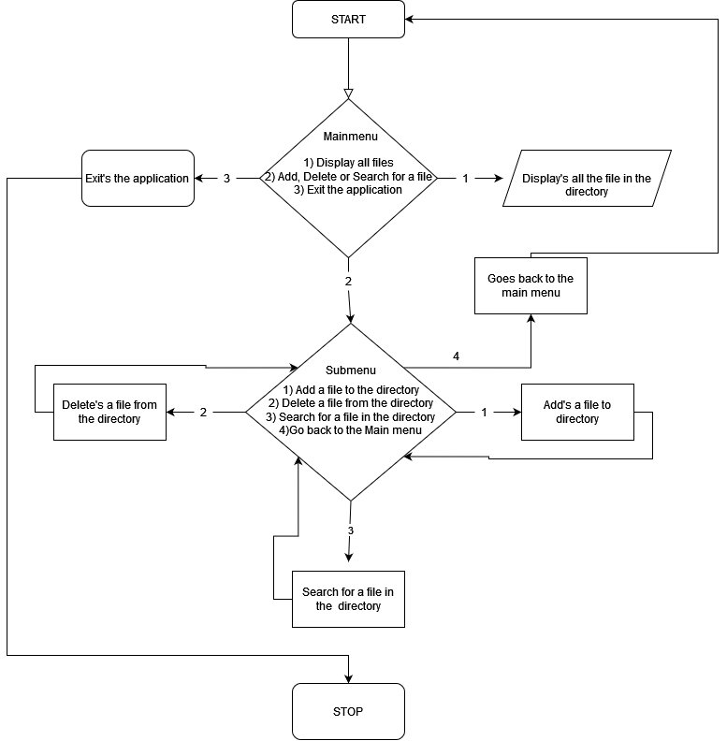

|  |
| --- |
| **SCREEN SHOTS:** |
| 1. Show all the files in the directory |
|  |
| 1. Add a file to the directory |
|  |

|  |
| --- |
| 1. Delete a file from the directory |
|  |
| 1. Search for a file in the directory |
|  |

|  |
| --- |
| 1. Files in the directory after above operations |
|  |
| 1. Exit the application |
|  |